PIZZA SALES SQL QUESRIES

1. KPI
2. Total Revenue

SELECT SUM(total_price) AS Total_Revenue from pizza_sales;

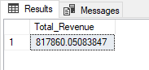

1. Average Order Revenue

SELECT (SUM(total_price) / COUNT(DISTINCT order_id)) AS Avg_Order_Value from pizza_sales;

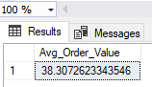

1. Total Pizza Sold

SELECT SUM(quantity) AS Total_Pizza_Sold from pizza_sales

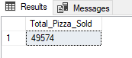

1. Total Orders Placed

SELECT COUNT(DISTINCT order_id) AS Total_Order from pizza_sales

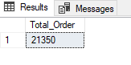

1. Average Pizzas Sold Per Order

SELECT CAST(CAST(SUM(quantity) AS DECIMAL(10,2)) /

CAST(COUNT(DISTINCT order_id) AS DECIMAL(10,2)) AS DECIMAL(10,2)) AS Avg_Pizza_Per_order from pizza_sales

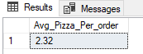

1. Daily Order Trend

SELECT DATENAME(DW, order_date) AS order_day, COUNT(DISTINCT order_id) AS Total_orders

from pizza_sales

GROUP BY DATENAME(DW, order_date)

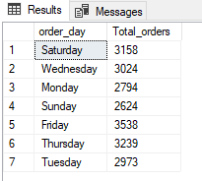

1. Monthly Order Trend

SELECT DATENAME(MONTH, order_date) AS Month_Name, COUNT(DISTINCT order_id) AS Total_orders

from pizza_sales

GROUP BY DATENAME(MONTH, order_date)

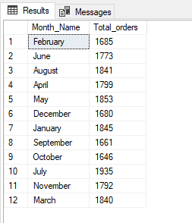

1. Percentage of Sales by Pizza Category

SELECT pizza_category, CAST(SUM(total_price) * 100 / (SELECT SUM(total_price) from pizza_sales) AS DECIMAL(10,2))AS Percenatge_Sales

from pizza_sales

GROUP BY pizza_category

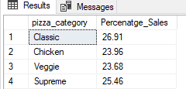

1. Percentage of Sales by Pizza Size

SELECT pizza_size, CAST(SUM(total_price) * 100 / (SELECT SUM(total_price) from pizza_sales) AS DECIMAL(10,2))AS Percenatge_Sales

from pizza_sales

GROUP BY pizza_size

ORDER BY Percenatge_Sales DESC

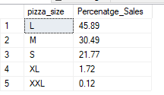

1. Best Selling Pizzas W.R.T Revenue (Top 5)

SELECT TOP 5 pizza_name, SUM(total_price) AS Total_Revenue

FROM pizza_sales

GROUP BY pizza_name

order by Total_Revenue DESC

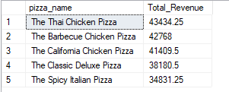

1. Worst Selling Pizzas W.R.T Revenue (Top 5)

SELECT TOP 5 pizza_name, SUM(total_price) AS Total_Revenue

FROM pizza_sales

GROUP BY pizza_name

order by Total_Revenue ASC

